**Ideation Phase**

**Define the Problem Statements**

|  |  |
| --- | --- |
| Date | 19 September 2022 |
| Team ID | PNT2022TMID39141 |
| Project Name | Digital Naturalist – AI Enabled tool for Biodiversity Researchers |
| Maximum Marks | 2 Marks |

**Problem Statement :**

* Biodiversity is the variation among living organisms from different sources including terrestrial, marine and desert ecosystems, and the ecological complexes of which they are a part.
* Biodiversity is the life support system.
* Biodiversity is the variety of different forms of life on earth, including the different plants , animals , micro–organism, the genes they contain & the ecosystem they form.

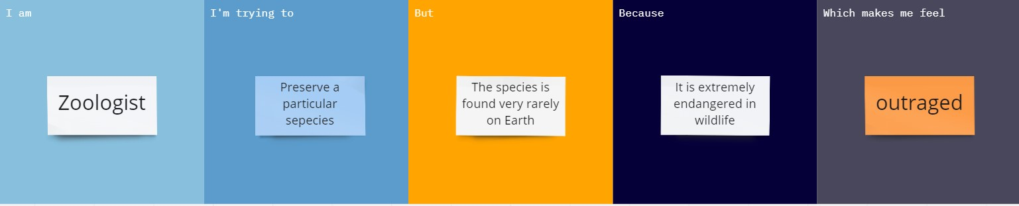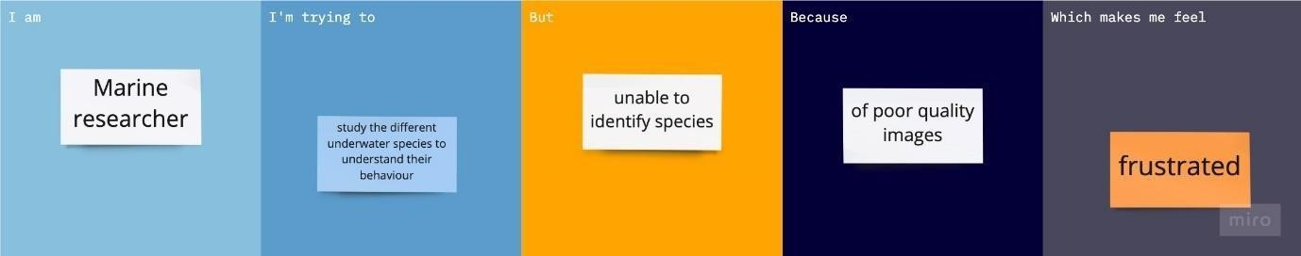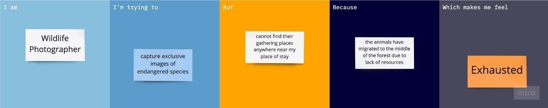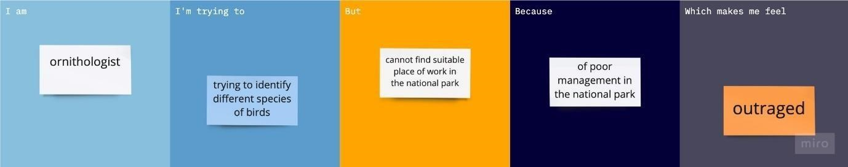

* Humans should not cause their voluntary extinction. Biodiversity preserves different cultures and spiritual heritage. Therefore, it is very important to conserve biodiversity
* There are millions of species of plant & animals ; every single variety could be valuable one day or the other.
* Human beings cannot exist without the abundance and diversity of these biological resources.

**Customer Problem Statement Template:**